**APPLICATIONS:**

1.It can be applied in public places such as malls, stations etc. To accurately sense and predict spot/vehicle occupancy in real-time. This helps in decreasing the traffic at a large extent and hence decreasing the pollution caused as well.

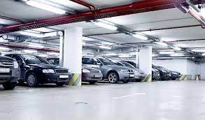

2. Guides residents and visitors to available parking spot and can be used to decrease the chaos caused in the societies especially in those where there are no allotted parkings.

3. Simplifies the parking experience and adds value for Parking stakeholders, such as merchants and drivers.

4. Enables intelligent decisions using data, including real–time status applications and historical analytics reports.

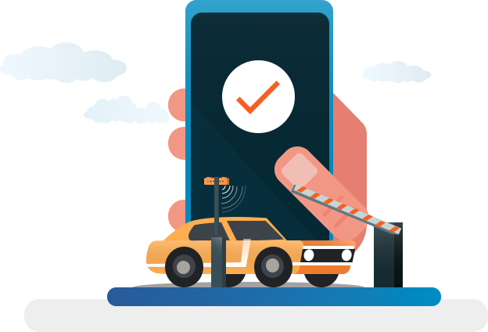

5.As discussed earlier Smart Parking plays an important role in creating better urban environment by reducing the emission of CO2 and other pollutants.

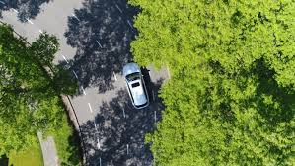

6.Smart Parking enables better and real time Monitoring and managing of available parking space which Results in significant revenue generation. Provides tools to optimize workforce management.

